When to Immunize Your Horse Against Common Diseases
Drs. Foster & Smith Educational Staff
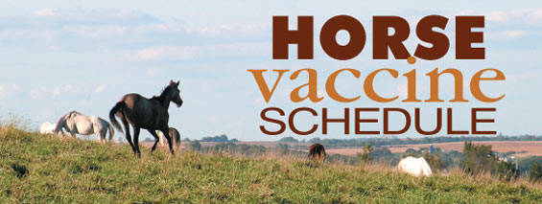
Vaccinate your horse against all diseases he may be exposed to, including at home or if you travel with your horse. The chart below is a guideline of the vaccines suggested for some general ages and classes of horses. Please consult your veterinarian for an individualized vaccine program for your horse, especially for broodmares.
Disease/Vaccine | Foals and Weanlings | Yearlings | Performance  or Pleasure  Horses
Tetanus toxoid | From non-vaccinated mare:  First dose: 3-4 months  Second dose: 4-5 months  From vaccinated mare:  First dose: 6 months  Second dose: 7 months  Third dose: 8-9 months | Annual | Annual
Equine  Encephalomyelitis,  Eastern, Western,  Venezuelan  (EEE,WEE,VEE) | EEE (in high-risk areas):  First dose: 3-4 months  Second dose: 4-5 months  Third dose: 5-6 months | Annual, spring | Annual, spring
 | WEE,EEE (in low-risk areas) and VEE:  From non-vaccinated mare:  First dose: 3-4 months  Second dose: 4-5 months  Third dose: 5-6 months  From vaccinated mare:  First dose: 6 months  Second dose: 7 months  Third dose: 8 months. | Annual, spring | Annual, spring
Influenza | Inactivated injectable:  From non-vaccinated mare:  First dose: 6 months  Second dose: 7 months  Third dose: 8 months,  then at 3-month intervals.  From vaccinated mare:  First dose: 9 months  Second dose: 10 months  Third dose: 11-12 months,  then at 3-month intervals. | Every 3-4 months. | Annual, with added boosters prior to likely exposure.
Influenza | Intranasal modified live virus:  First dose: 11 months, or as your veterinarian recommends. | Every 6 months. | Every 6 months.
Rhinopneumonitis  (EHV-1 and EHV-4) | First dose: 4-6 months  Second dose: 5-7 months  Third dose: 6-8 months,  then at 3-month intervals. | Booster every 3 to 4 months up to annually. | Performance horses: Booster every 3-4 months up to annually.  Pleasure horses: Optional: semi-annual if elected.
West Nile Virus | First dose: 3-4 months  Second dose: 1 month later  (plus 3rd dose at 6 months in areas at risk) | Annual booster, prior to expected risk. Vaccinate semi-annually or more frequently (every 4 months), depending on risk. | Annual booster, prior to expected risk. Vaccinate semi-annually or more frequently (every 4 months), depending on risk.
Strangles | Injectable:  First dose: 4-6 months  Second dose: 5-7 months  Third dose: 7-8 months (depending on product used)  Fourth dose: 12 months  Intranasal:  First dose: 6-9 months  Second dose: 3 weeks later | Semi-annual | Optional: semi-annual if risk is high.
Potomac Horse Fever | First dose: 5-6 months  Second dose: 6-7 months | Semi-annual | Semi-annual
Botulism (inactivated type B toxoid) | From vaccinated mare:  3-dose series of toxoid at 30-day intervals, starting at 2-3 months of age.  From non-vaccinated mare:  Consult your veterinarian | Consult your veterinarian | Consult your veterinarian
Equine Viral Arteritis | Intact colts intended to be breeding stallions: one dose at 6-12 months of age. | Annual for colts intended to be breeding stallions | Annual for colts intended to be breeding stallions
Rotavirus A | Little value to vaccination of foals because there is insufficient time to develop antibodies for protection during susceptible age. | Not applicable | Not applicable
Rabies | Consult your veterinarian | Consult your veterinarian | Consult your veterinarian
*As with administration of all medications, the label and product insert should be read before administration of all vaccines. Please consult your veterinarian for recommendations for an individualized vaccination program for your horse.

